# 9. GRADIENT, DIVERGENCE AND CURL

## Aim:

* To write Matlab codes to visualize the vector field of 2-Dimension as well as 3-Dimension.
* To find the gradient vector and visualize it with contour curves.
* To find divergence, curl and scalar potential

## Mathematical form:

## Draw the two dimensional vector field for the vector =(x, y) + (x,y)

### Draw the three dimensional vector field for the vector =(x,y,z)+ (x,y,z) +(x,y,z)

* Find the gradient vector for the following function F(x,y) at the point (x1,y1) .

let the given function be f(x,y). grad (f)=(∂f/∂x) +(∂f/∂y). Then [grad (f)] at (a,b) is

(∂f/∂x) (a,b) + (∂f/∂y) (a,b).

* Find the directional derivative of the function F(x,y,z) in the direction of the vector = V1 + V2 + V3 the point (x1,y1,z1).

Let the given function be F(x,y,z). Find[ grad f] at (x1,y1,z1). Find the unit tangent normal by /] at(x1,y1,z1). Then directional derivative is given by (gradf).(/].

## MATLAB Syntax used:

|  |  |
| --- | --- |
| inline(expr) | Constructs an inline function object from the MATLAB expression contained in the string expr. |
| vectorize(fun) | Inserts a . before any ^, * or / in s. The result is a character string |
| quiver(x,y,u,v) | Displays velocity vectors as arrows with components (u,v) at the points (x,y) |
| quiver3(x,y,z,u,v,w) | Plots vectors with components (u,v,w) at the points (x,y,z)) |
| vectarrow(p0,p1) | Plots a line vector with arrow pointing from point p0 to point p1. The function can plot both 2D and 3D vector with arrow depending on the dimension of the input |
| [g](https://in.mathworks.com/help/symbolic/sym.gradient.html?searchHighlight=gradient&s_tid=srchtitle_gradient_2#mw_0358c2bd-ebb0-43b0-8aed-800c2de86644) = gradient([f](https://in.mathworks.com/help/symbolic/sym.gradient.html?searchHighlight=gradient&s_tid=srchtitle_gradient_2#buiegd5-f)) | finds the gradient vector of the scalar function f with respect to a vector constructed from all symbolic scalar variables found in f. The order of variables in this vector is defined by [symvar](https://in.mathworks.com/help/symbolic/symvar.html). |

## Example 1:

Draw the two dimensional vector field for the vector +

## MATLAB Code:

clc

clear all

syms x y

F=input( 'enter the vector as i, and j order in vector form:');

P = inline(vectorize(F(1)), 'x', 'y');

Q = inline(vectorize(F(2)), 'x', 'y');

x = linspace(-1, 1, 10);

y = x;

[X,Y] = meshgrid(x,y);

U = P(X,Y);

V = Q(X,Y);

quiver(X,Y,U,V,1)

axis on

xlabel('x')

ylabel('y')

**Output:**

In the Command window:

Enter the vector as i,j and k order in vector form:[x y]

In the Figure window:

-0.2

0

0.2

0.4

0.6

0.8

1

1.2

-0.2

0

0.2

0.4

0.6

0.8

1

1.2

x

y

## Example 2:

Draw the three dimensional vector field for the vector - +

## MATLAB Code:

syms x y z

F=input( 'enter the vector as i,j and korder in vector form:')

P = inline(vectorize(F(1)), 'x', 'y','z');

Q = inline(vectorize(F(2)), 'x', 'y','z');

R = inline(vectorize(F(3)), 'x', 'y','z');

x = linspace(-1, 1, 5); y = x;

z=x;

[X,Y,Z] = meshgrid(x,y,z);

U = P(X,Y,Z);

V = Q(X,Y,Z);

W = R(X,Y,Z);

quiver3(X,Y,Z,U,V,W,1.5)

axis on

xlabel('x')

ylabel('y')

zlabel('z')

## Output:

In the Command Window:

enter the vector as i, j and k order in vector form:[x -y z]

F =[ x, -y, z]

In the figure window:



## Example 3:

Find the gradient vector field of . Plot the gradient vector field together with a contour map of f. How are they related?

## MATLAB Code:

clc

clear all

syms x y

f=input( 'enter the function f(x,y):');

F=gradient(f)

P = inline(vectorize(F(1)), 'x', 'y');

Q = inline(vectorize(F(2)), 'x','y');

x = linspace(-2, 2, 10);

y = x;

[X,Y] = meshgrid(x,y);

U = P(X,Y);

V = Q(X,Y);

quiver(X,Y,U,V,1)

axis on

xlabel('x')

ylabel('y')

hold on

ezcontour(f,[-2 2])

## Output:

Command Window:

enter the function f(x,y):

x^2*y-y^3

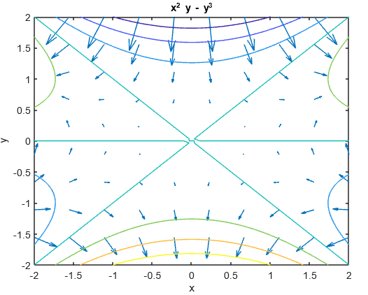

## Inference:

The gradient vectors are orthogonal to the contours.

**Example 4**

Find (a) the curl and (b) the divergence of the vector field.



**Matlab code**

clc

clear all

syms x y z real

F=input( 'enter the vector as i, j and k order in vector form:')

curl_F = curl(F, [x y z])

div_F = divergence(F, [x y z])

**Output:**

enter the vector as i,j and k order in vector form:

[x^2*y*z x*y^2*z x*y*z^2]  
F =  
[x^2*y*z, x*y^2*z, x*y*z^2]  
curl_F =  
   
 x*z^2 - x*y^2  
 y*x^2 - y*z^2  
- z*x^2 + z*y^2  
   
div_F =  
   
6*x*y*z

**Example 5**

Determine whether or not the vector field  is conservative. If it is conservative, find a function f such that .

**Matlab code**

clc

clear all

syms x y z real

F=input( 'enter the vector as i,j and k order in vector form:')

curl_F = curl(F, [x y z])

if (curl_F ==[0 0 0])

f = potential(F, [x y z])

else

sprintf('curl_F is not equal to zero')

end

**Output:**

curl_F =   
0  
0  
0   
f =   
x*y^2*z^3

Exercise

1. Plot the gradient vector field of *f* together with a contour map of *f* . Explain how they are related to each other
2. (b) (c)
3. Determine whether or not the vector field is conservative. If it is conservative, find a function f such that .